Crossword Puzzle

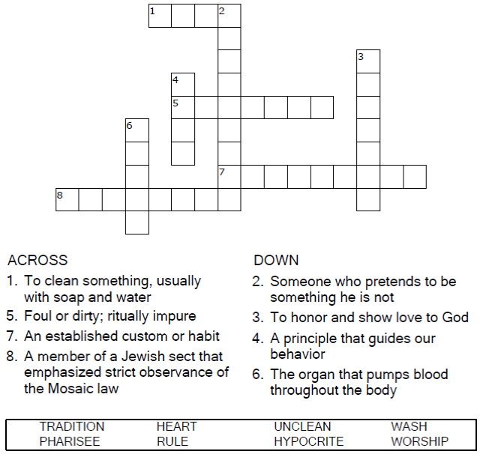



Copyright © Sermons4Kids, Inc.

May be reproduced for Ministry Use

**Children’s Worship Bulletin**



Mark 7:1-8

Word Search Puzzle

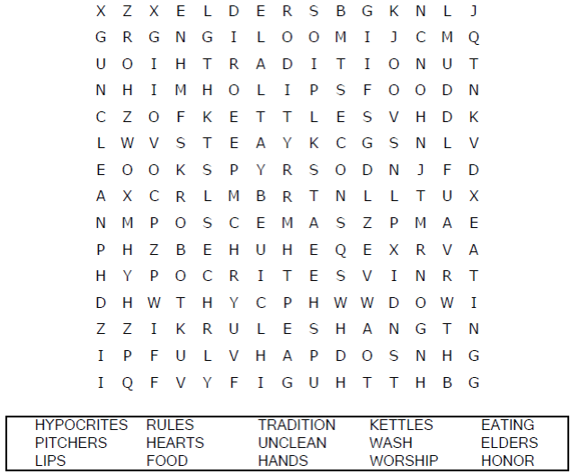  
  
**Church Name  
Address  
City**

Coloring Page

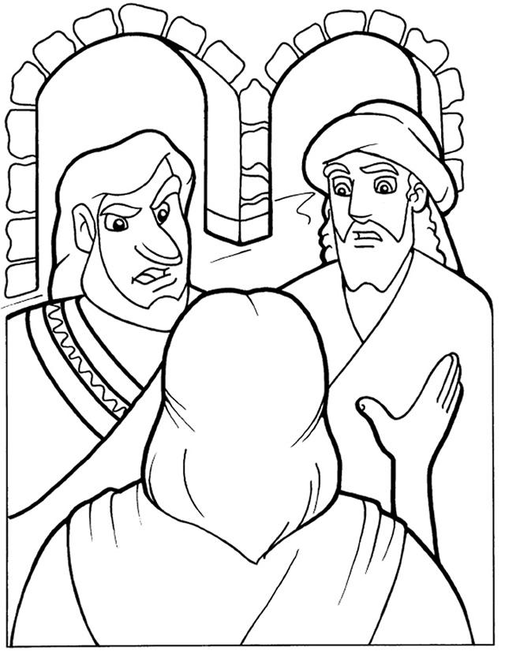

"These people honor me with their lips,  
but their hearts are far from me."

Mark 7:6  
  
Copyright © CalvaryCurriculum.com  
Used by Permission

Maze Puzzle

You can’t judge apples (or people)  
by their outward appearance.

