Crossword Puzzle

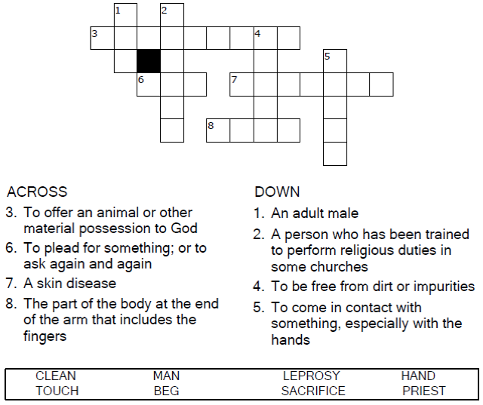



Copyright © Sermons4Kids, Inc.

May be reproduced for Ministry Use

Children’s Worship Bulletin



Mark 1:40-45

Word Search

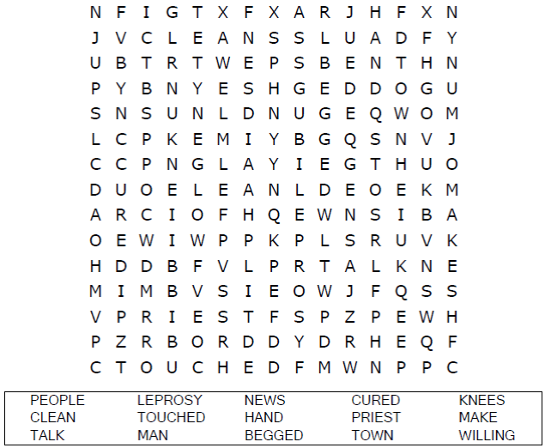

**Your Church Name Here**Any Town, Anywhere

Decoder Puzzle

Each number represents a letter of the alphabet.  
Substitute the correct letter for the numbers  
to reveal the coded words.

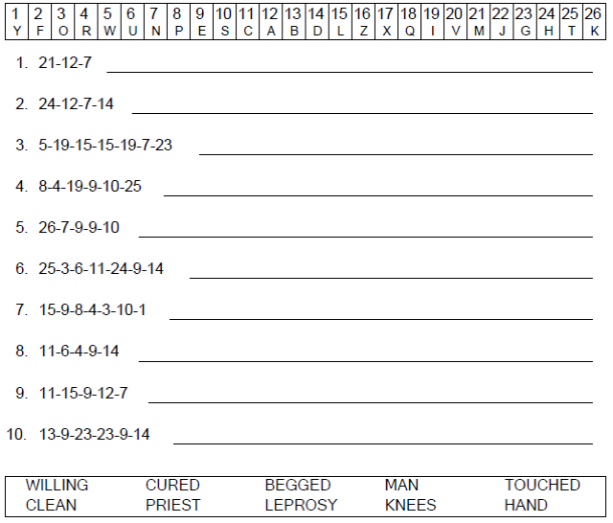



Color Me

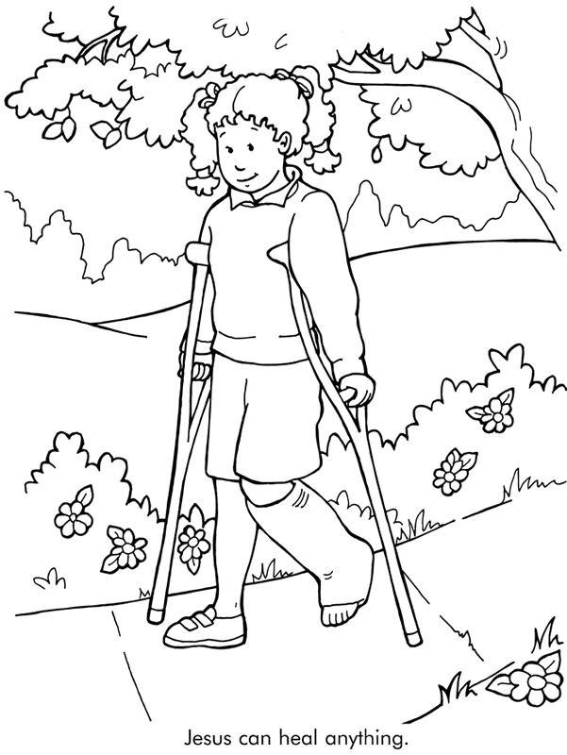

From Thru-the-Bible Coloring Pages for Ages 4-8. © 1986,1988 Standard Publishing.

Used by permission. Reproducible Coloring Books may be purchased from

Standard Publishing, www.standardpub.com, 1-800-543-1301.