Crossword Puzzle

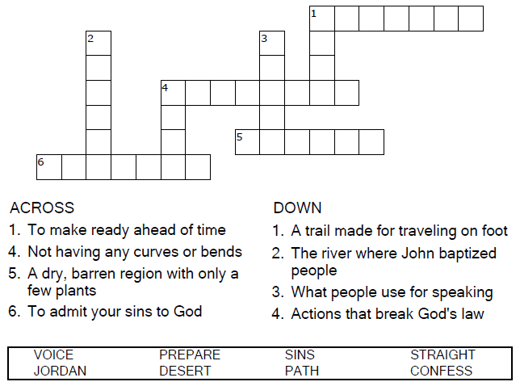

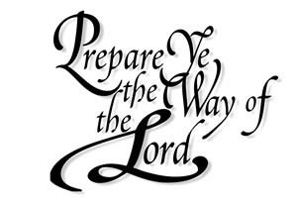  
  
Copyright © Sermons4Kids, Inc.

May be reproduced for Ministry Use

Children’s Worship Bulletin



Mark 1:1-8

Word Search

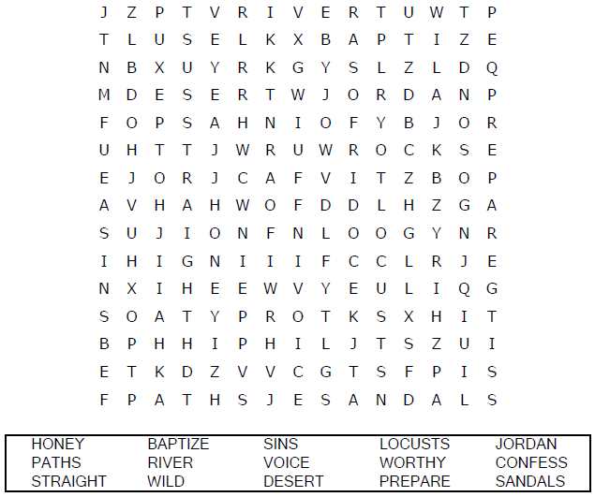

**Church Name**

**Address  
City**

Decoder Puzzle

Each number represents a letter of the alphabet. Substitute  
 the correct letter for the numbers to reveal the coded words.

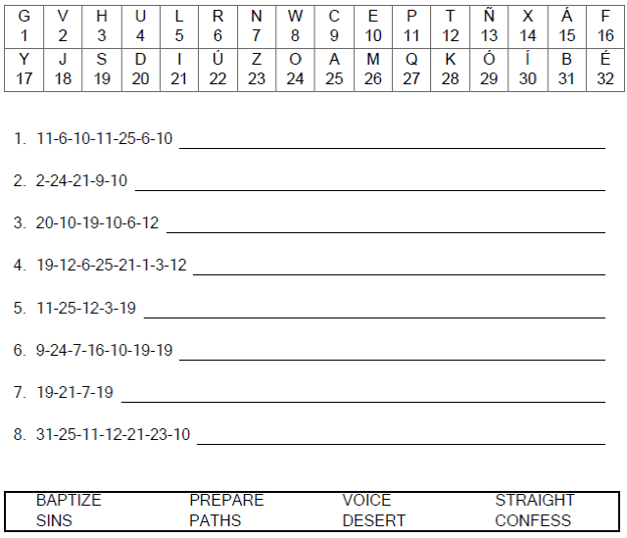

Copyright Sermons4Kids, Inc.

Free Use for Ministry Purposes

Color Me!

