Crossword Puzzle

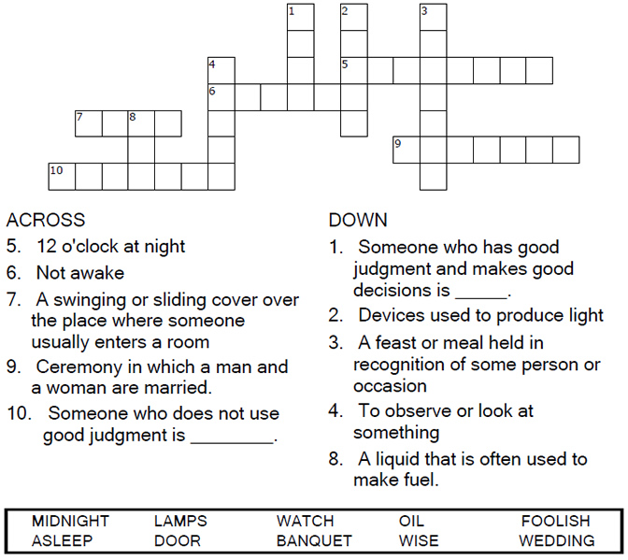



Copyright © Sermons4Kids, Inc.

May be reproduced for Ministry Use

Children’s Worship Bulletin



Matthew 25:1-13

Word Search Puzzle

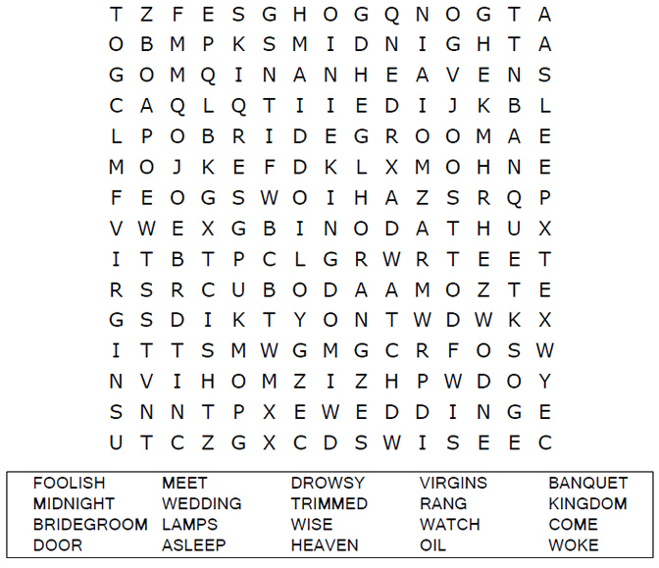

**Your Church Name Here**

Anytown, USA

Coloring Page

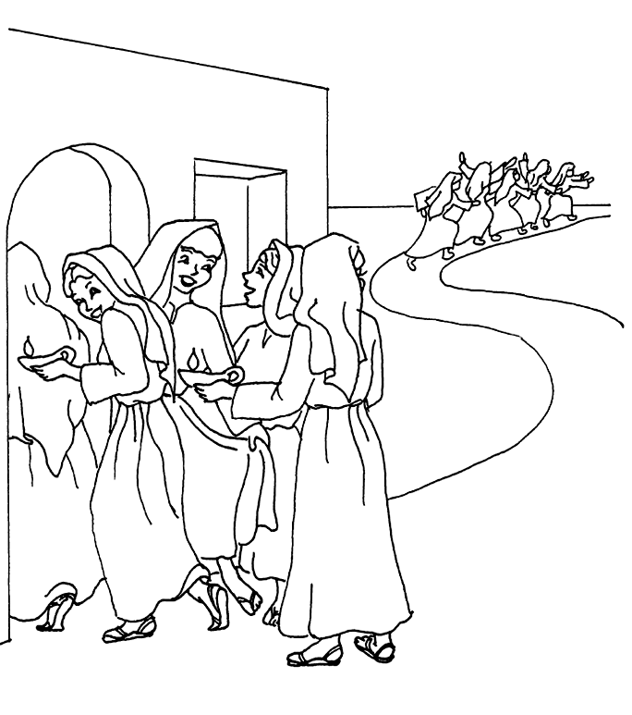

**The Parable of the Ten Bridesmaids  
Matthew 25:1-13**

Copyright © CalvaryCurriculm.com  
Used by Permission

Multiple Choice Quiz

