Crossword Puzzle

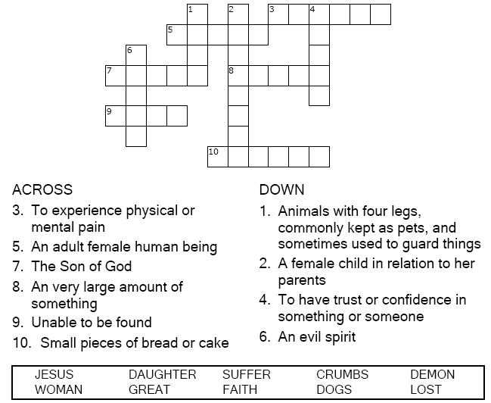



Copyright © Sermons4Kids, Inc.

May be reproduced for Ministry Use

**Children’s Worship Bulletin**



Matthew 15:21-28

Word Search Puzzle

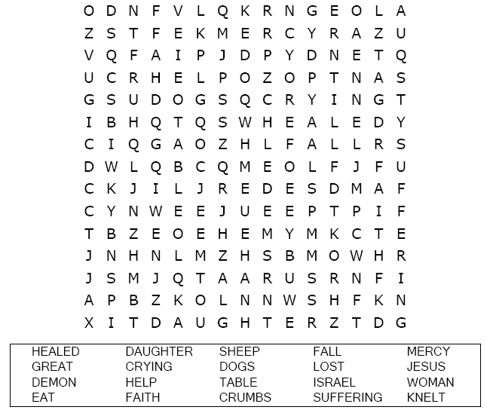  
  
**Your Church’s Name  
Address  
City, State**

Coloring Page

  
  
Jesus Loves Everyone  
From Thru-the-Bible Coloring Pages for Ages 4-8. © 1986,1988 Standard Publishing.  
Used by permission. Reproducible Coloring Books may be purchased from  
Standard Publishing, [www.standardpub.com](http://www.standardpub.com/), 1-800-543-1301.

Multiple Choice Quiz

Choose the word that best fits the definition.

