Crossword Puzzle

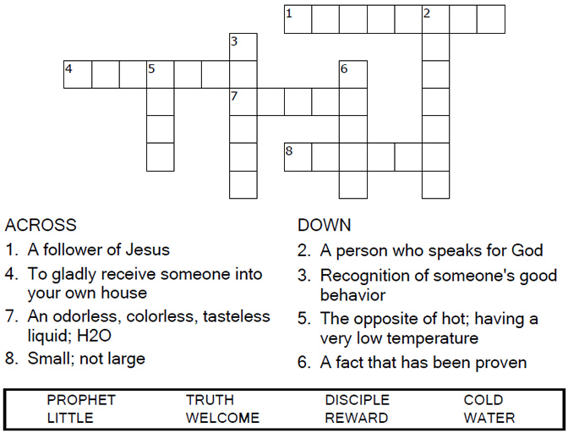

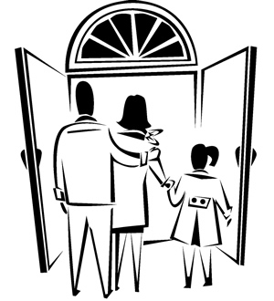

Copyright © Sermons4Kids, Inc.

May be reproduced for Ministry Use

**Children’s Worship Bulletin**



Mathew 10:40-42

Word Search Puzzle

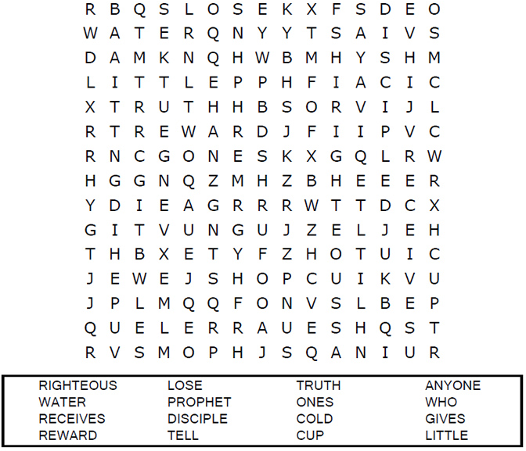  
  
**church_border.jpeg**

Coloring Page

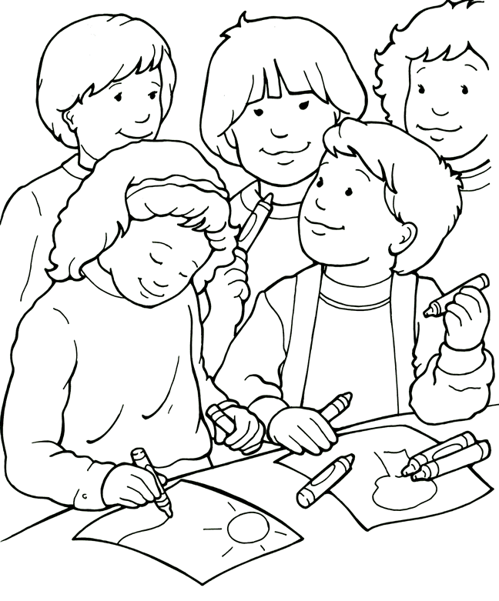  
I can make others feel welcome by being friendly.

From Thru-the-Bible Coloring Pages. © 1986,1988 Standard Publishing.

Used by permission. Reproducible Coloring Books may be purchased from

Standard Publishing, www.standardpub.com, 1-800-323-7543.

Decoder Puzzle

Each number represents a letter of the alphabet. Substitute  
the correct letter for the numbers to reveal the coded words.

