Crossword Puzzle

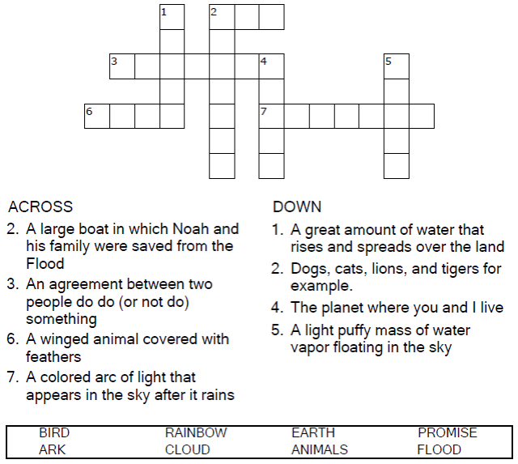



Copyright © Sermons4Kids, Inc.

May be reproduced for Ministry Use

Children’s Worship Bulletin



Genesis 9:8-17

Word Search

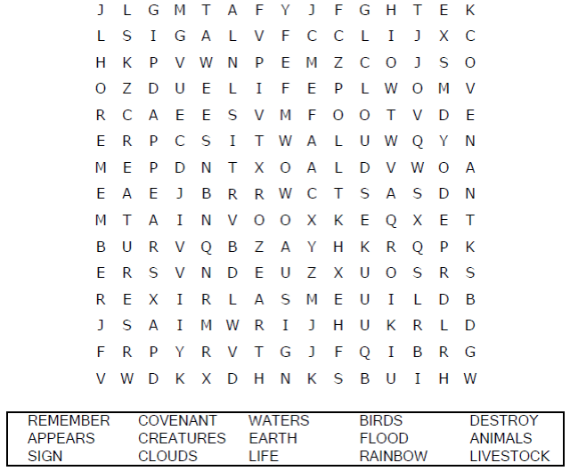

Your Church Name  
City or Town

Decoder Puzzle

Each number represents a letter of the alphabet. Substitute  
the correct letter for the numbers to reveal the coded words.

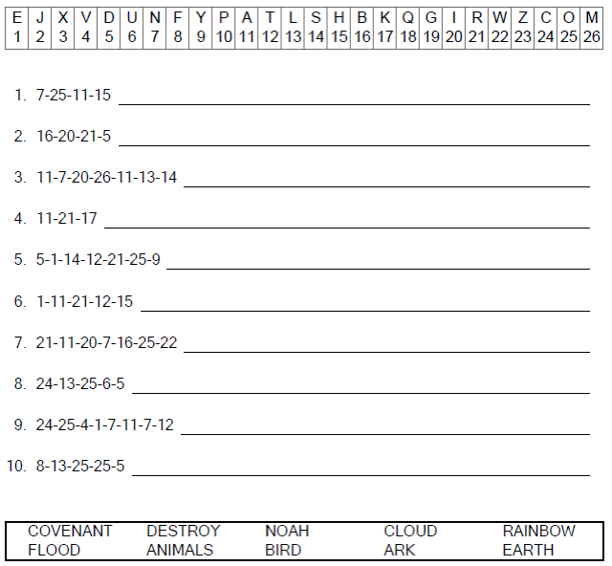



Coloring Page

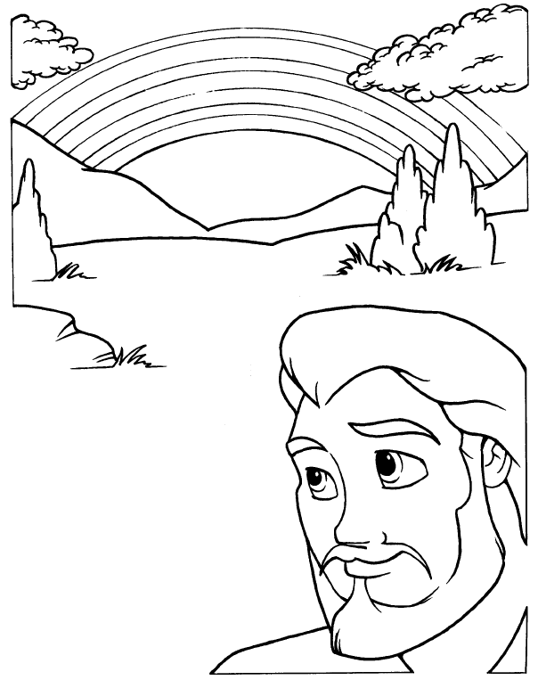

**GOD’S PROMISE TO ALL LIFE ON THE EARTH**

“Whenever the rainbow appears in the clouds, I will see it and  
remember the everlasting covenant between God and all  
living creatures of every kind on the earth.”  
Genesis 9:16 (NIV)