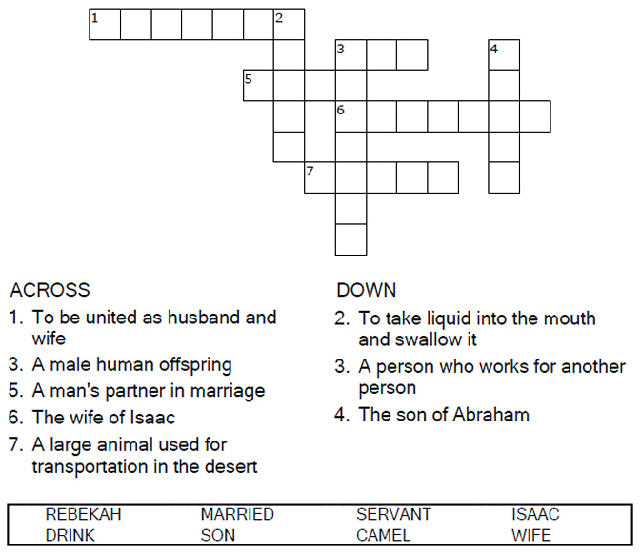
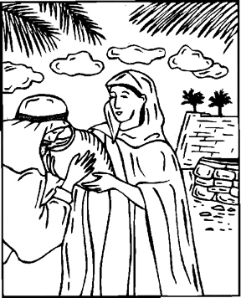

Copyright © Sermons4Kids, Inc.
May be reproduced for Ministry Use
Children’s Worship Bulletin

A Bride for Isaac

Genesis 24:1-67

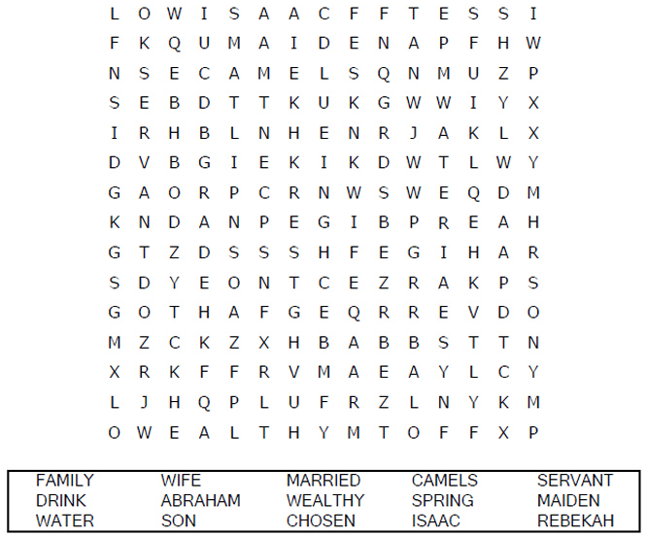
Your Church Name
Church Address
City

A Bride for Isaac
Genesis 24:1-67
Copyright © CalvaryCurriculum.com
Used by Permission

Each number represents a letter of the alphabet. Substitute
correct letter for the numbers to reveal the coded words.

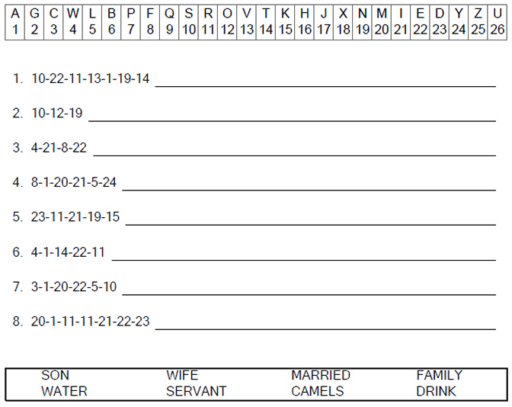

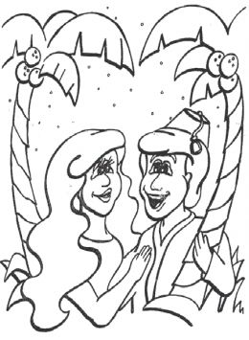
Isaac and Rebekah

