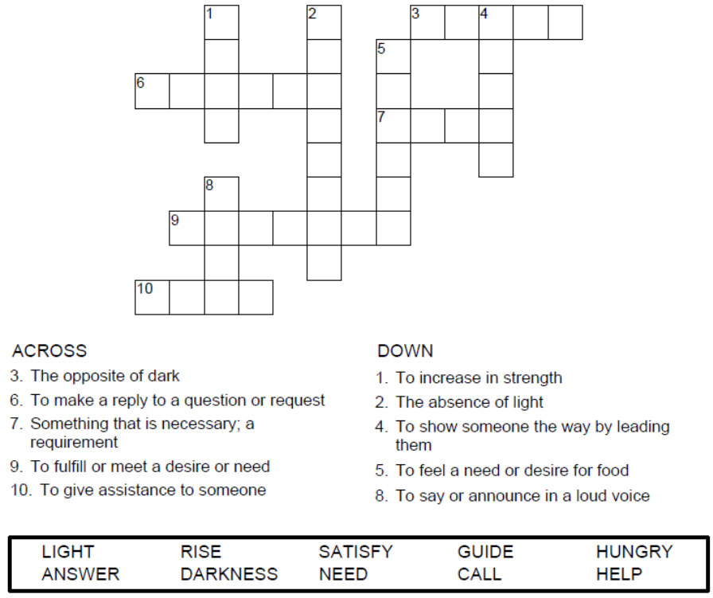
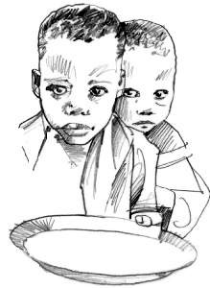

Copyright © Sermons4Kids, Inc.
May be reproduced for Ministry Use
Children’s Worship Bulletin

Feed the Children

Isaiah 58:9-12

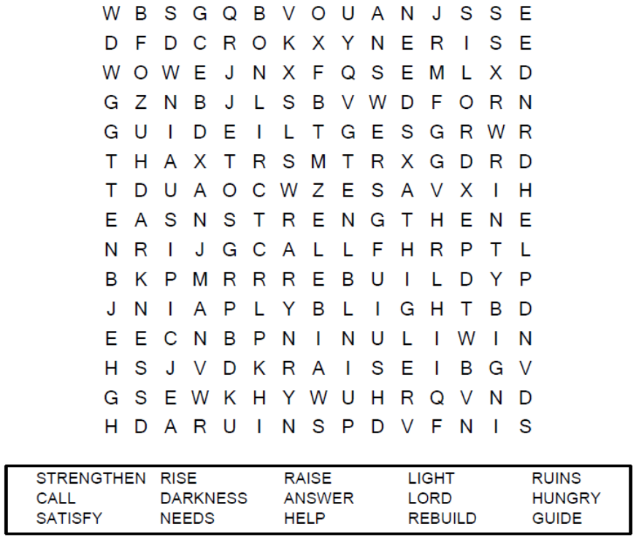

Your Church Name Here
Anytown, Anywhere

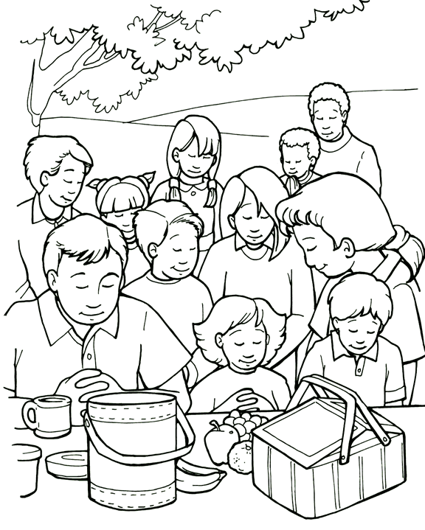
Jesus can feed a crowd with a little food.

From Thru-the-Bible Coloring Pages for Ages 4-8. © Standard Publishing.
Used by permission. Reproducible Coloring Books may be purchased from
Standard Publishing, www.standardpub.com, 1-800-543-1301.

Each number represents a letter of the alphabet. Substitute
the correct letter for the numbers to reveal the coded words.




