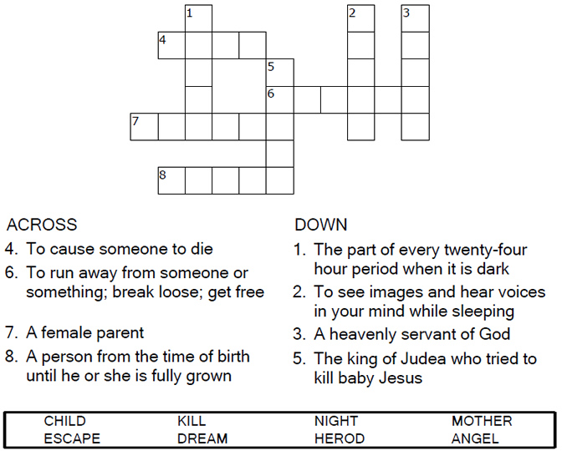
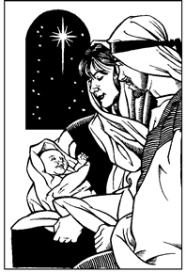

Copyright © Sermons4Kids, Inc.
May be reproduced for Ministry Use
Children’s Worship Bulletin

Flight to Egypt

Matthew 2:13-23

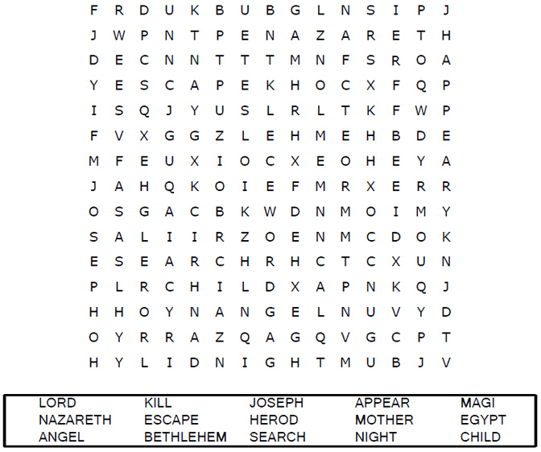

Your Church Name
City or Town

Each number represents a letter of the alphabet. Substitute
correct letter for the numbers to reveal the coded words.
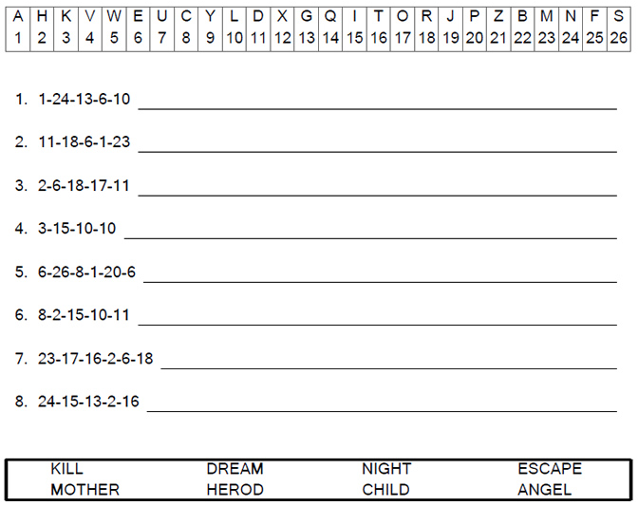
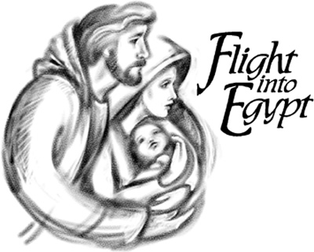

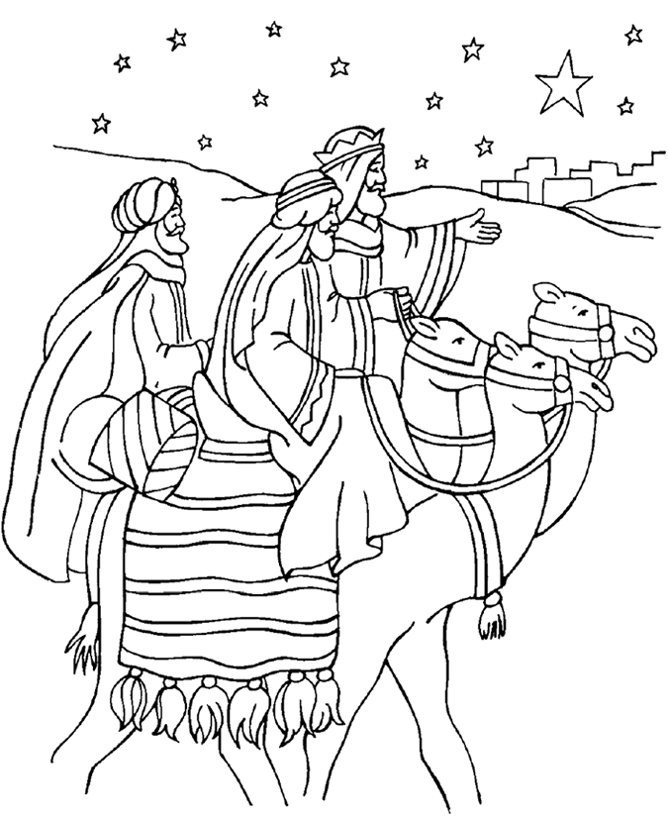

Wise Men Worship Jesus
Matthew 2

From Thru-the-Bible Coloring Pages for Ages 4-8. © 1986,1988 Standard Publishing.
Used by permission. Reproducible Coloring Books may be purchased from
Standard Publishing, www.standardpub.com, 1-800-543-1301.

