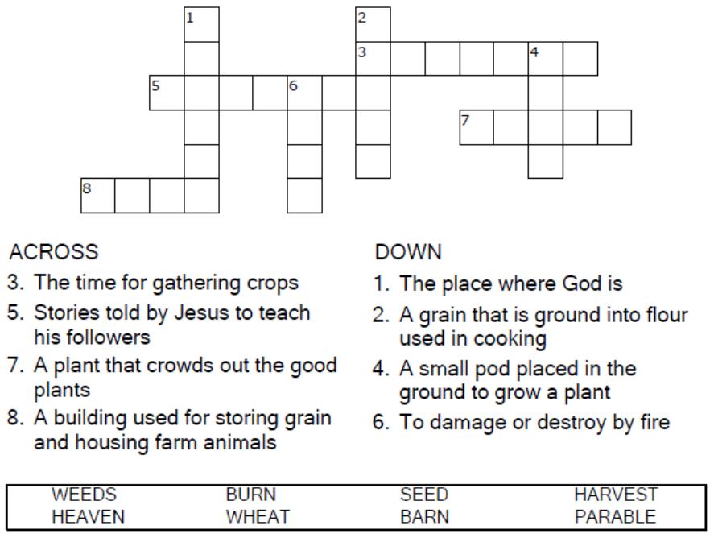


Copyright © Sermons4Kids, Inc.
May be reproduced for Ministry Use
Children’s Worship Bulletin

The Parable of the Weeds

Matthew 13:24-29

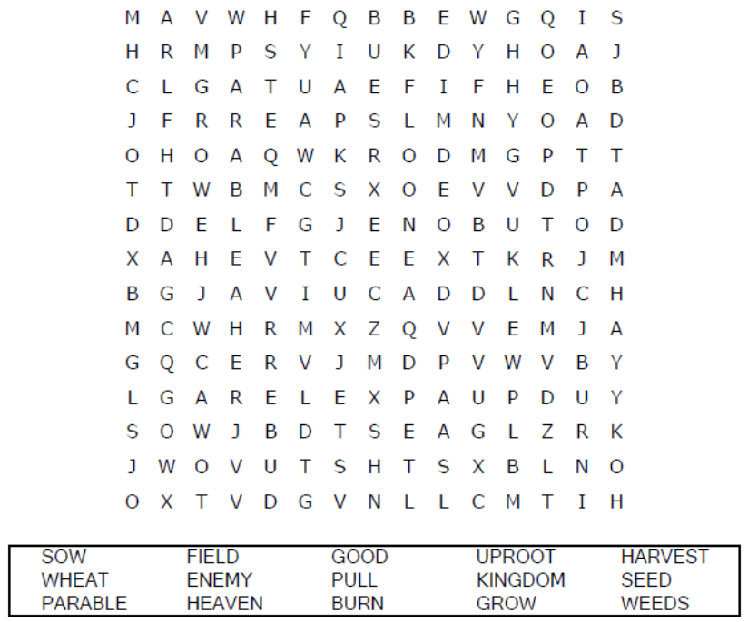

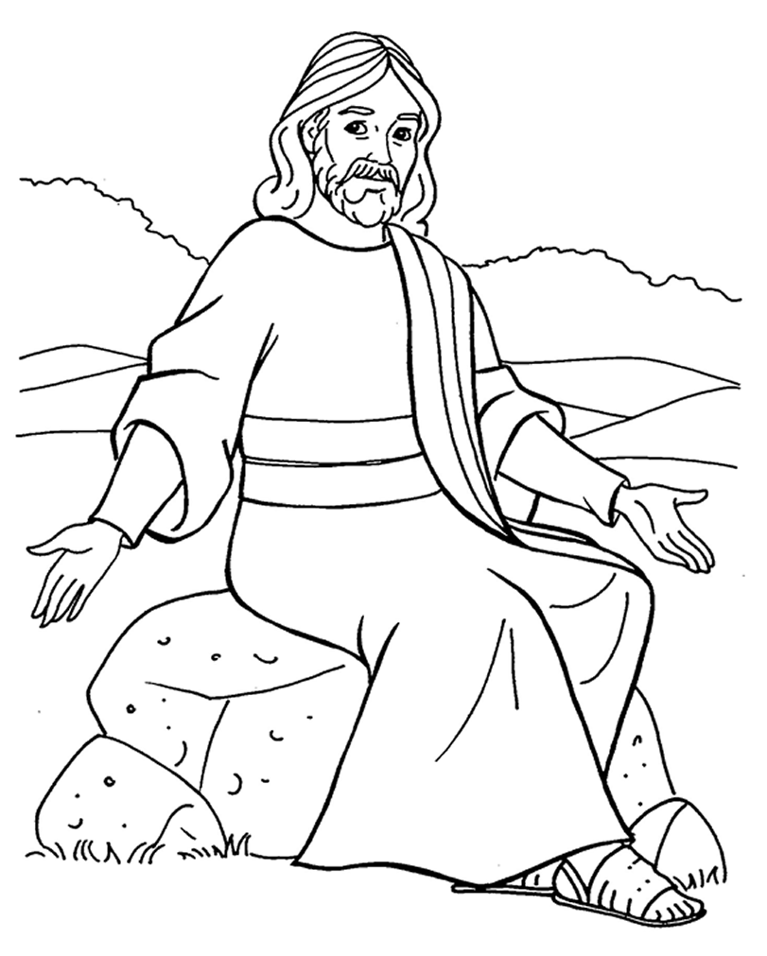
The Parable of the Weeds
Copyright © CalvaryCurriculum.com
Used by Permission

Each number represents a letter of the alphabet.
Substitute the correct letter for the numbers
to reveal the coded words.



