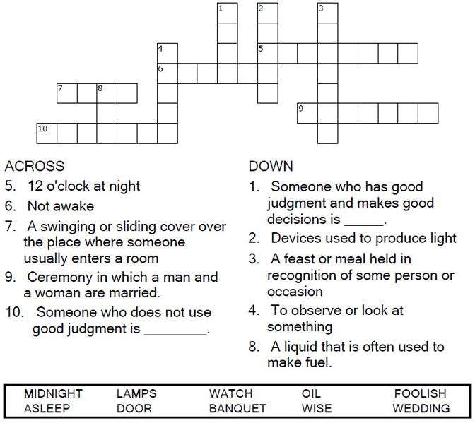


Copyright © Sermons4Kids, Inc.
May be reproduced for Ministry Use

Children’s Worship Bulletin

Be Prepared

Matthew 25:1-13

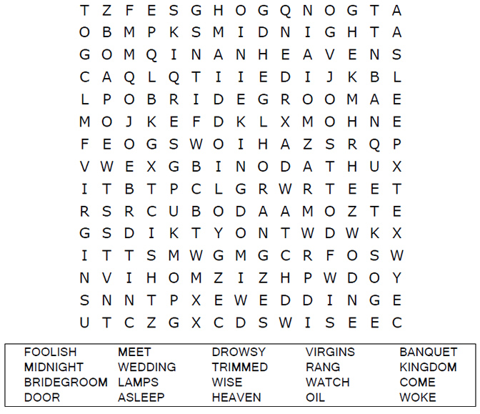
Your Church Name Here
Anytown, USA

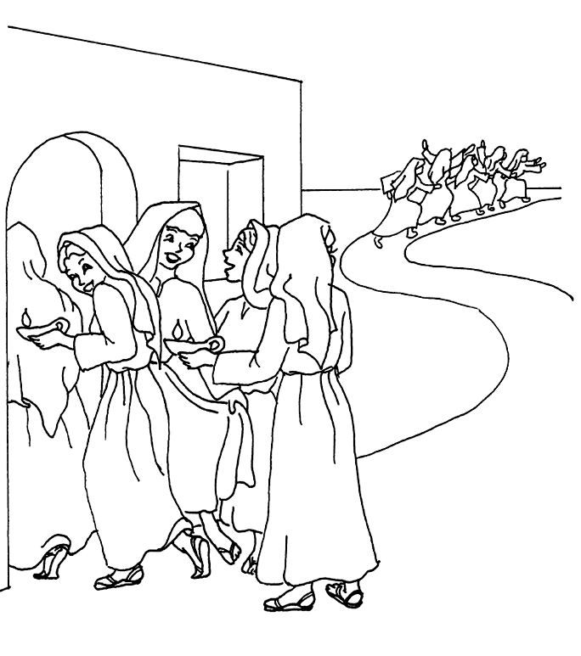
The Parable of the Ten Bridesmaids
Matthew 25:1-13

Copyright © CalvaryCurriculm.com
Used by Permission



