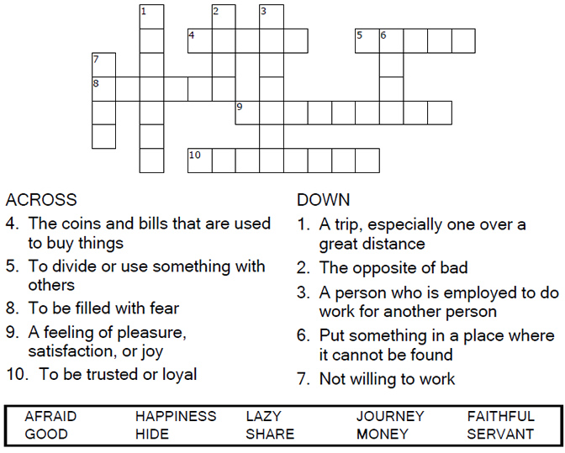

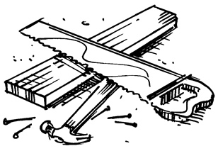
Copyright © Sermons4Kids, Inc.
May be reproduced for Ministry Use

Children’s Worship Bulletin

Parable of the Talents

Matthew 25:14-30

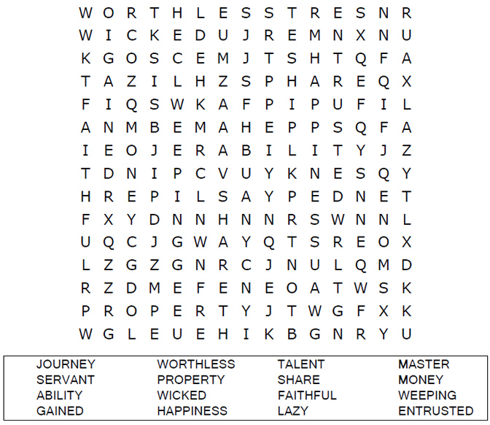
Church Name Here
Church Address
City

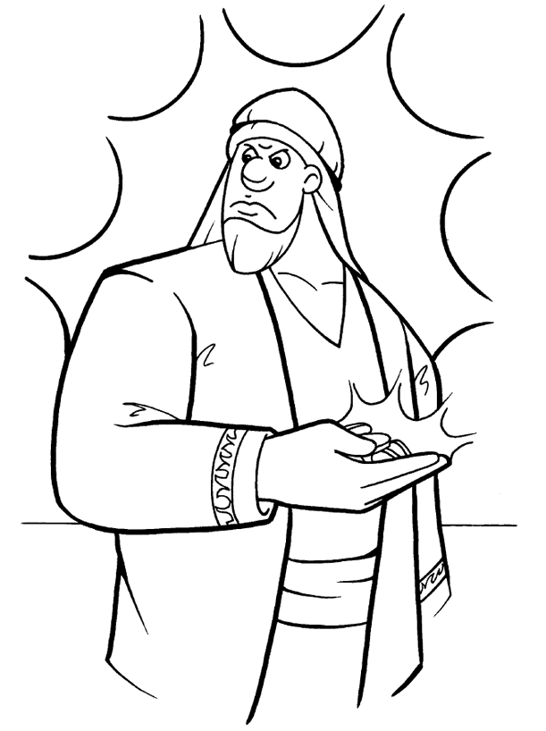
The Parable of the Talents
Matthew 25:14-30

Copyright © CalvaryCurriculm.com
Used by Permission





