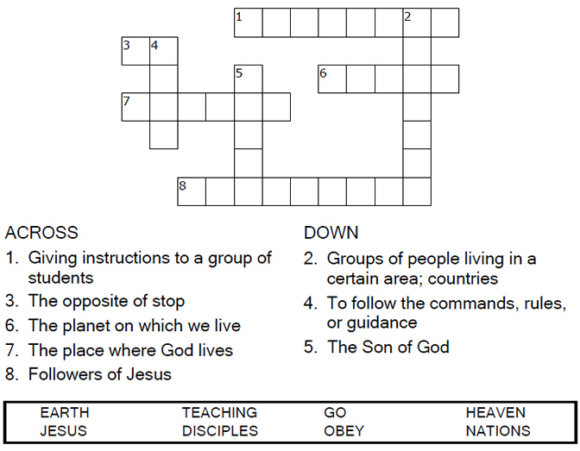


Copyright © Sermons4Kids, Inc.
May be reproduced for Ministry Use
Children’s Worship Bulletin

The Great Commission

Matthew 28:16-20

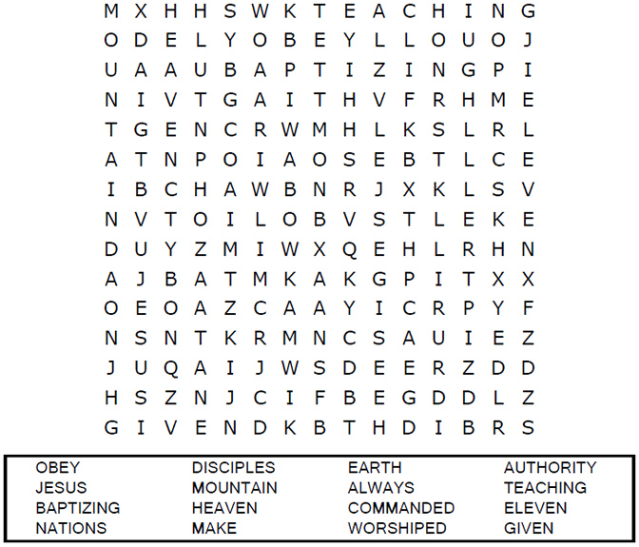


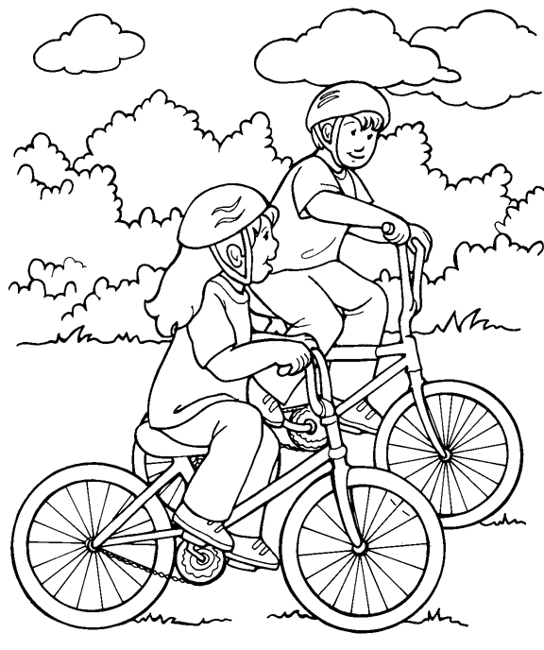
I can tell my friends about Jesus.

From Thru-the-Bible Coloring Pages for Ages 4-8. © Standard Publishing.
Used by permission. Reproducible Coloring Books may be purchased from
Standard Publishing, www.standardpub.com, 1-800-543-1301.

I can help my friends find the way to Jesus!



