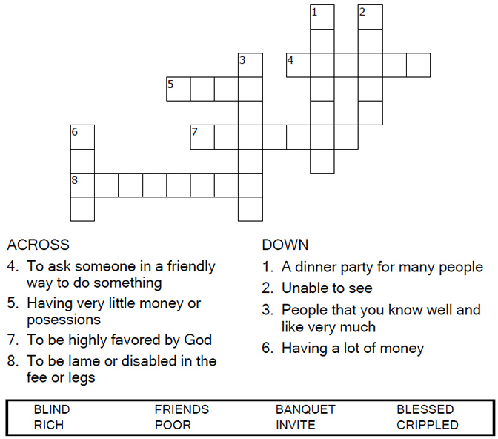


Copyright © Sermons4Kids, Inc.
May be reproduced for Ministry Use
Children’s Worship Bulletin

Left Out?

Luke 14:12-14

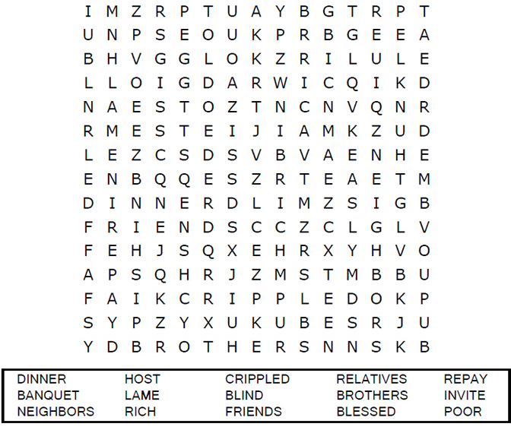

Your Church Name Here
Your City or Town


Happy are those people who are fair, who do what is right at all times.
Psalm 106:3
From Thru-the-Bible Coloring Pages for Ages 4-8. © 1986,1988 Standard Publishing
Used by permission. Reproducible Coloring Books may be purchased from
Standard Publishing, www.standardpub.com,1-800-543-1301.




