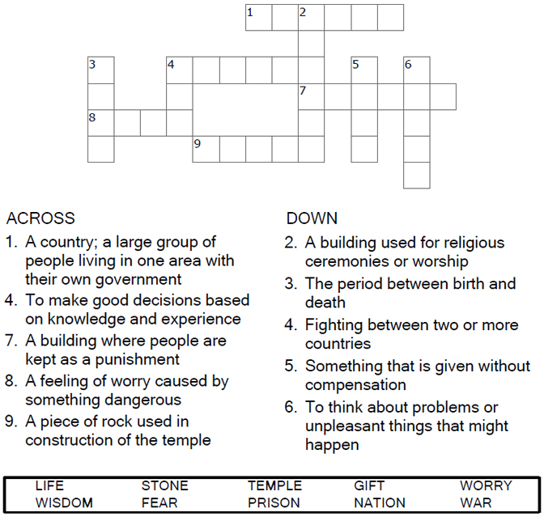


Copyright © Sermons4Kids, Inc.
May be reproduced for Ministry Use
Children’s Worship Bulletin

When I Am Afraid

Luke 21:5-19

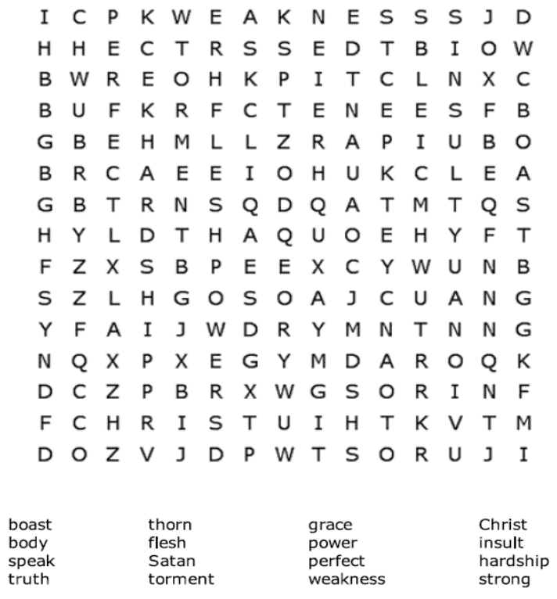

Your Church Name
Address
City

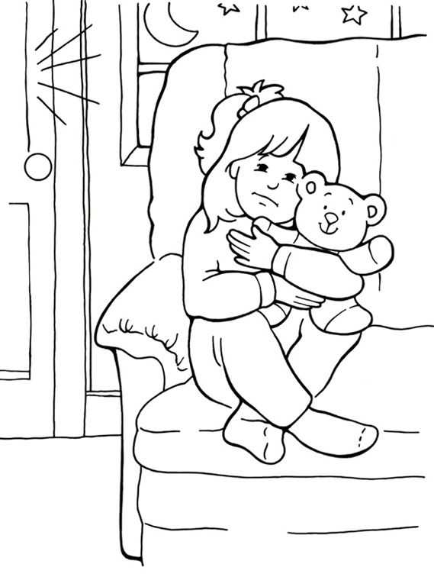
God is with me when I am afraid.

From Thru-the-Bible Coloring Pages for Ages 4-8. © Standard Publishing.
Used by permission. Reproducible Coloring Books may be purchased from
Standard Publishing, www.standardpub.com, 1-800-543-1301.

Each number represents a letter of the alphabet. Substitute
the correct letter for the numbers to reveal the coded words.




