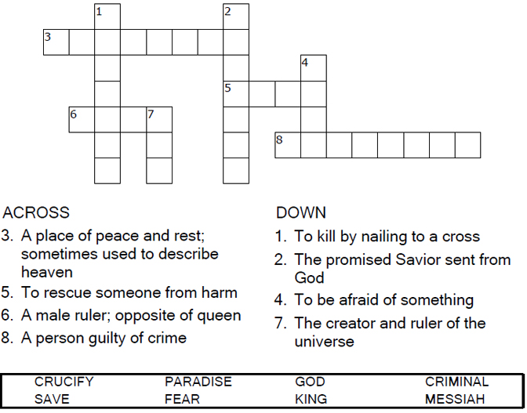


Copyright © Sermons4Kids, Inc.
May be reproduced for Ministry Use
Children’s Worship Bulletin

King Backward

Luke 23:33-43

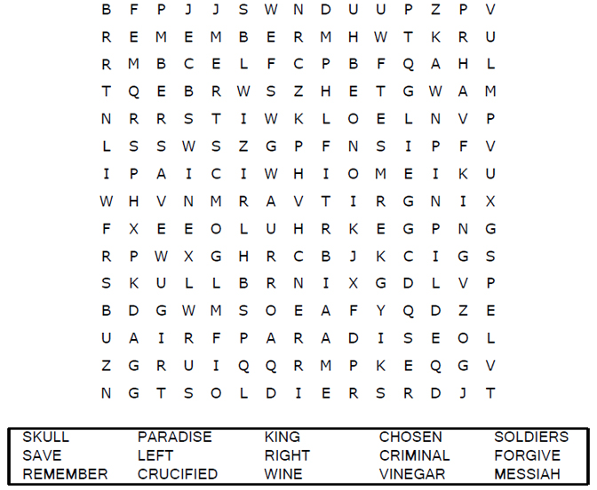

Your Church Name
Address
City

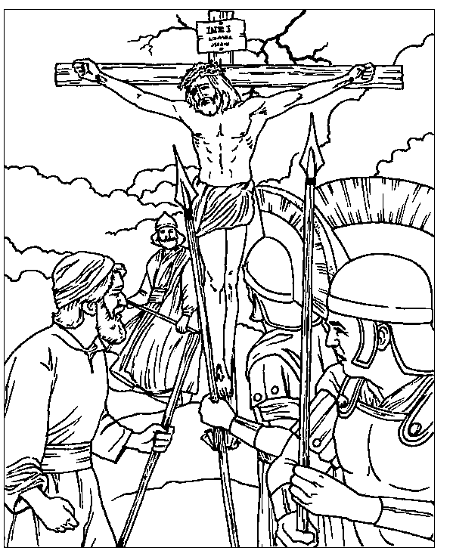

From BibleStoryCard Learning System(tm) Coloring Book © 1996
Wesleyan Publishing House. Used by permission. Additional
BibleStoryCard resources are available by calling 1-800-493-7539
or by visiting the Wesleyan Publising House web site.
http://www.parable.com/wph/group_1052.htm

Each number represents a letter of the alphabet. Substitute
the correct letter for the numbers to reveal the coded words.




