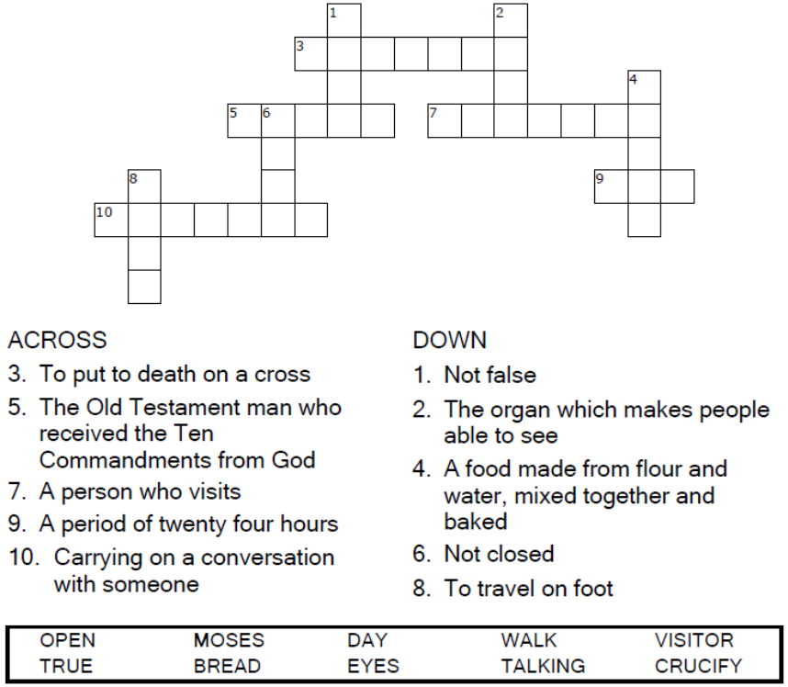
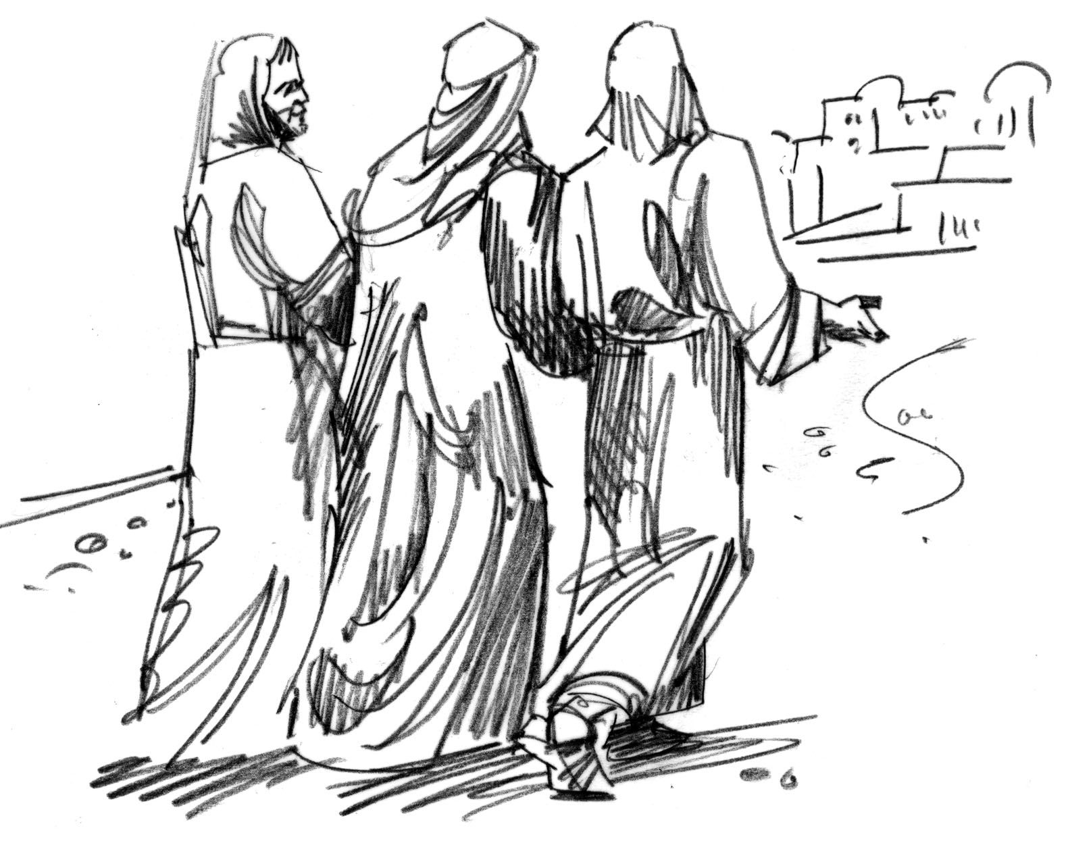

Copyright © Sermons4Kids, Inc.
May be reproduced for Ministry Use
Children’s Worship Bulletin

On the Road to Emmaus

Luke 24:13-35

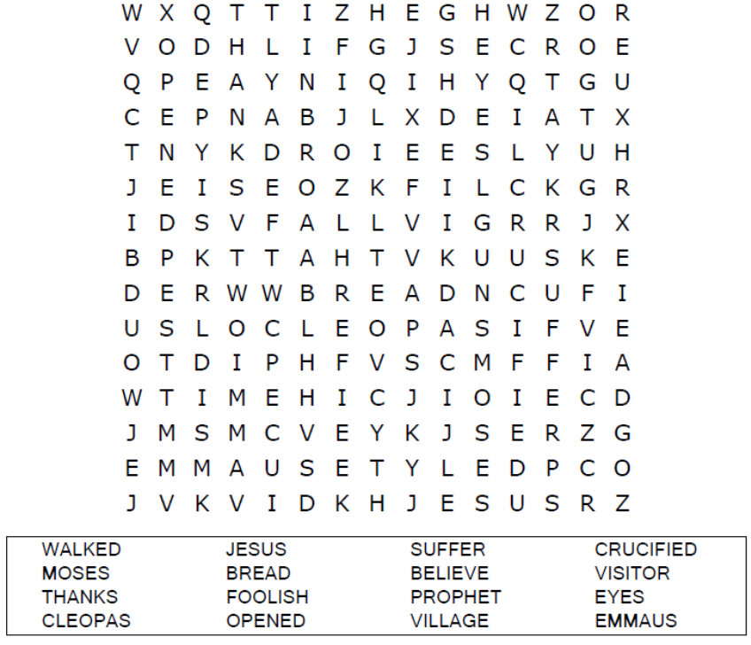


Follow Jesus on the road to Emmaus




The Road to Emmaus
Copyright © CalvaryCurriculum.com
Used by Permission

