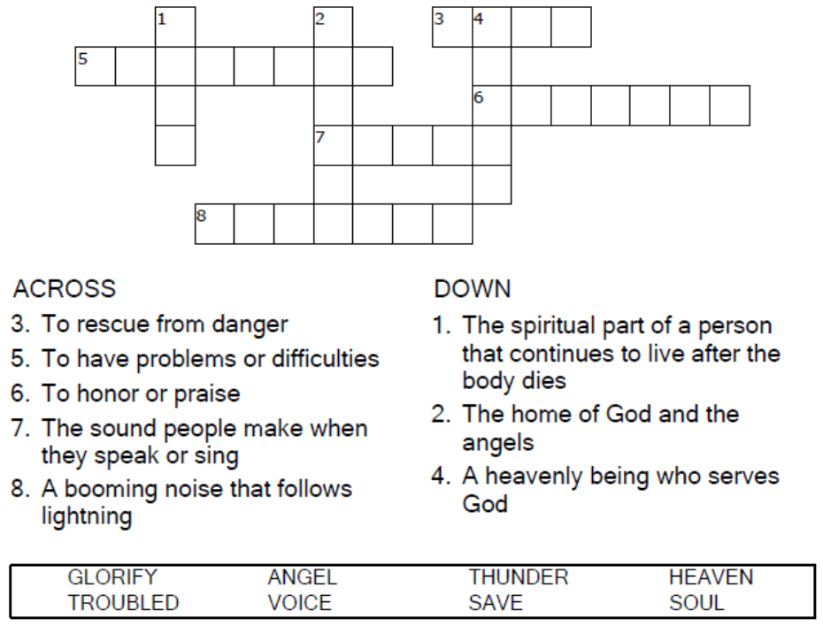
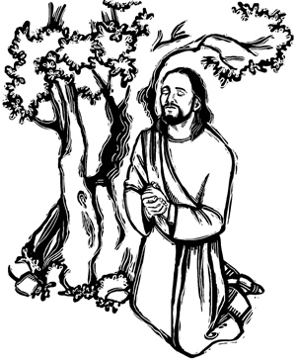
Copyright © Sermons4Kids, Inc.
May be reproduced for Ministry Use
Children’s Worship Bulletin

"My Soul Is Troubled"

John 12:27-29

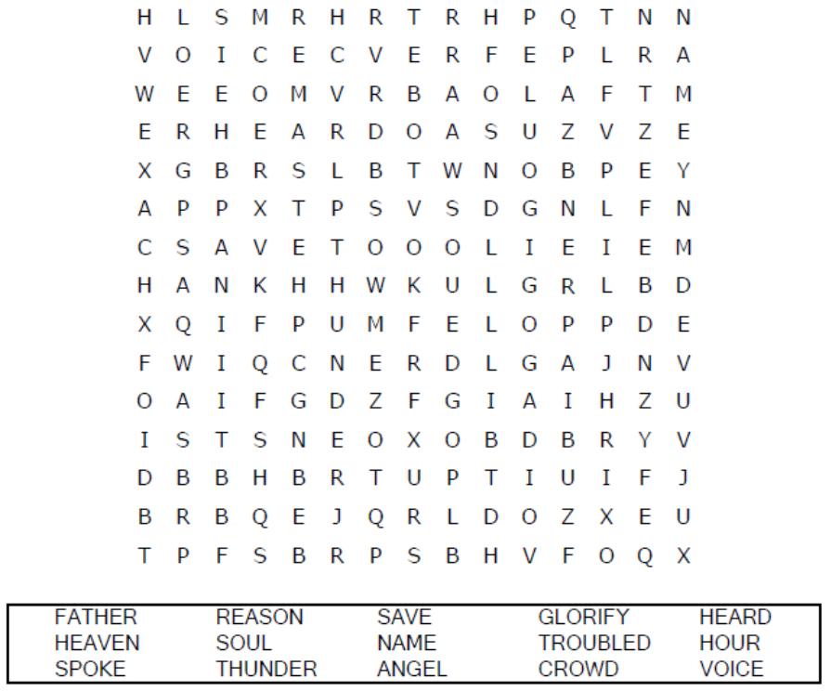

Your Church Name Here
Anytown, Anywhere

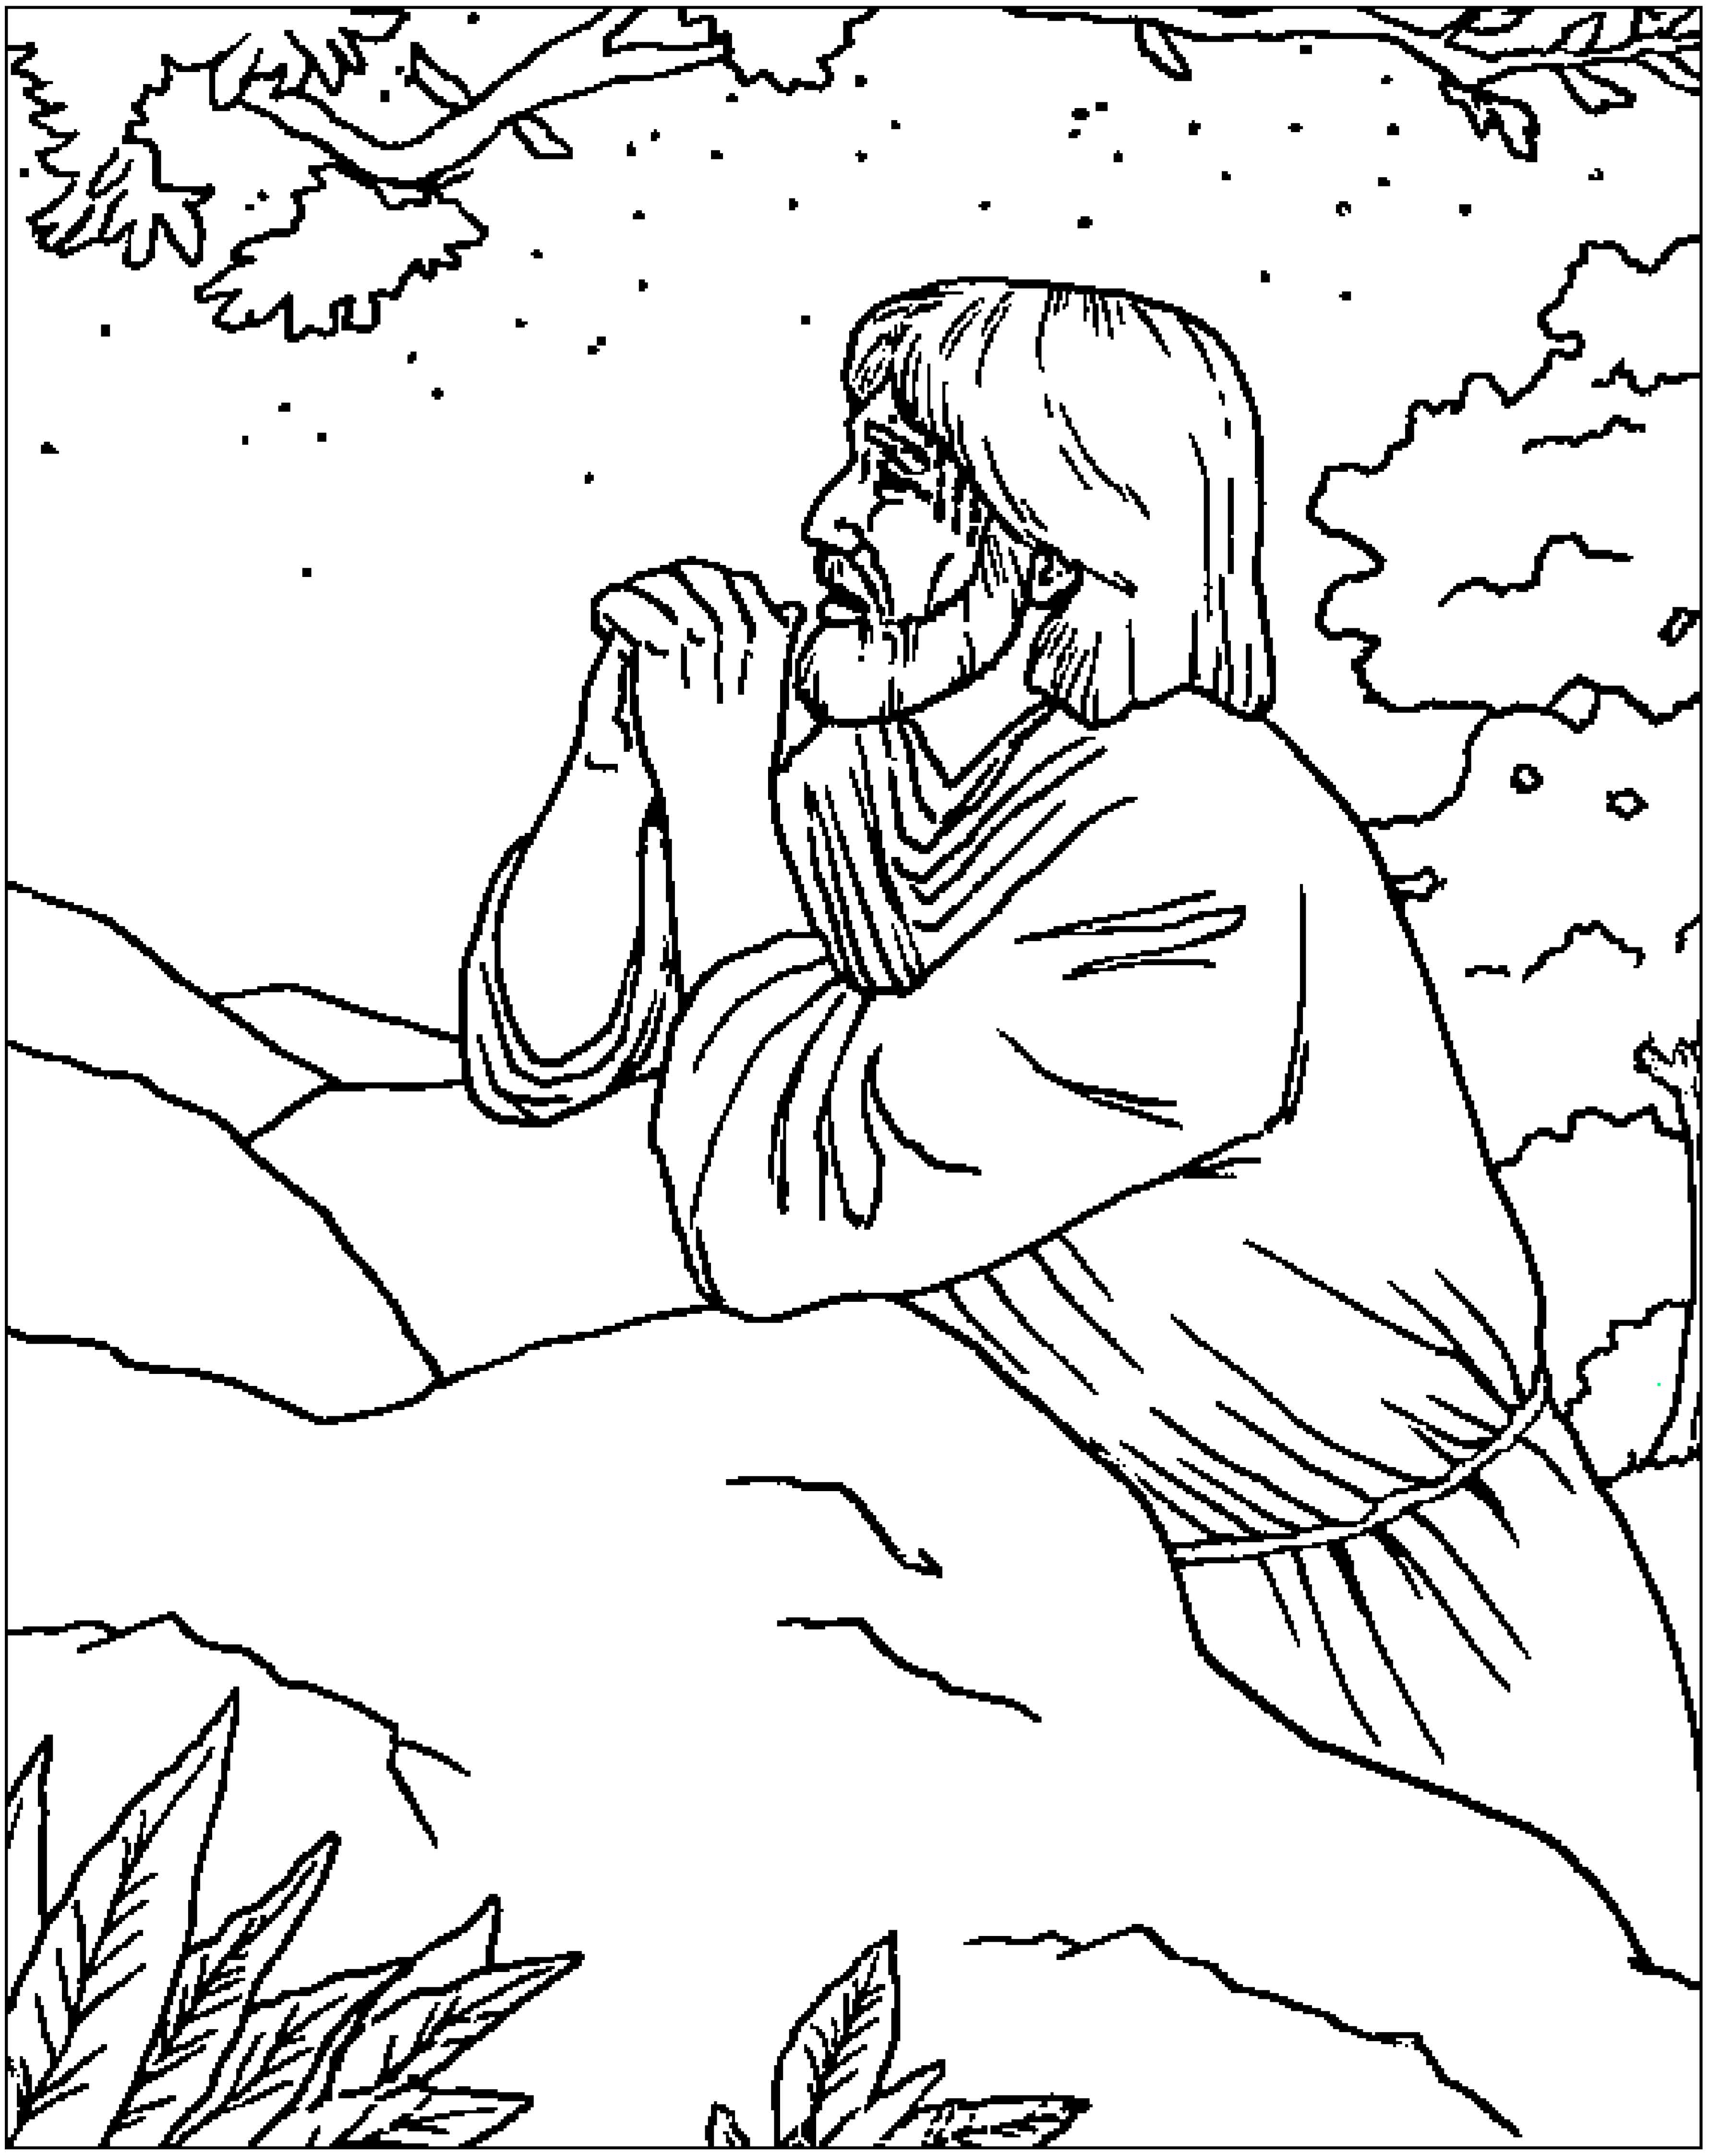

“Now my heart is troubled, and what shall I say?
‘Father, save me from this hour?’ No it was
for this very reason I came to this hour.”
John 12:27 (NIV)

From BibleStoryCard Learning System'M Coloring Book© 1996 Wesleyan Publishing
House. Used by permission. Additional resources available by calling 1-800-493-7539
or visiting on line. https://wphstore.com/



