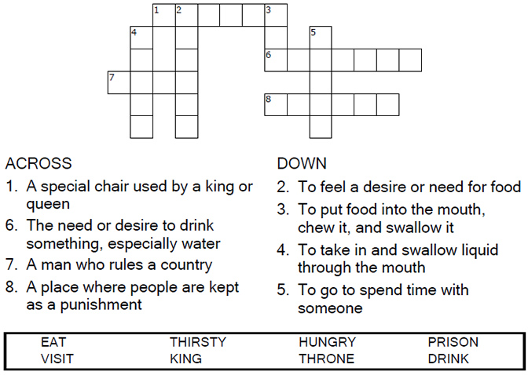

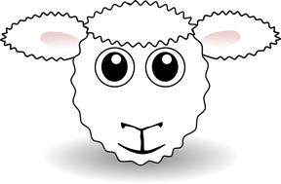
Copyright © Sermons4Kids, Inc.
May be reproduced for Ministry Use

Children’s Worship Bulletin

The Sheep and the Goats

Matthew 25:31-46

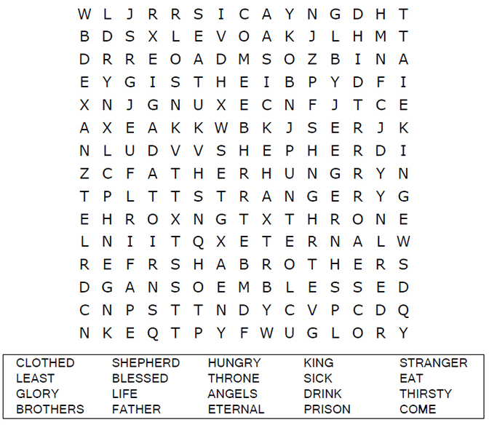
Church Name Here
Church Address
City

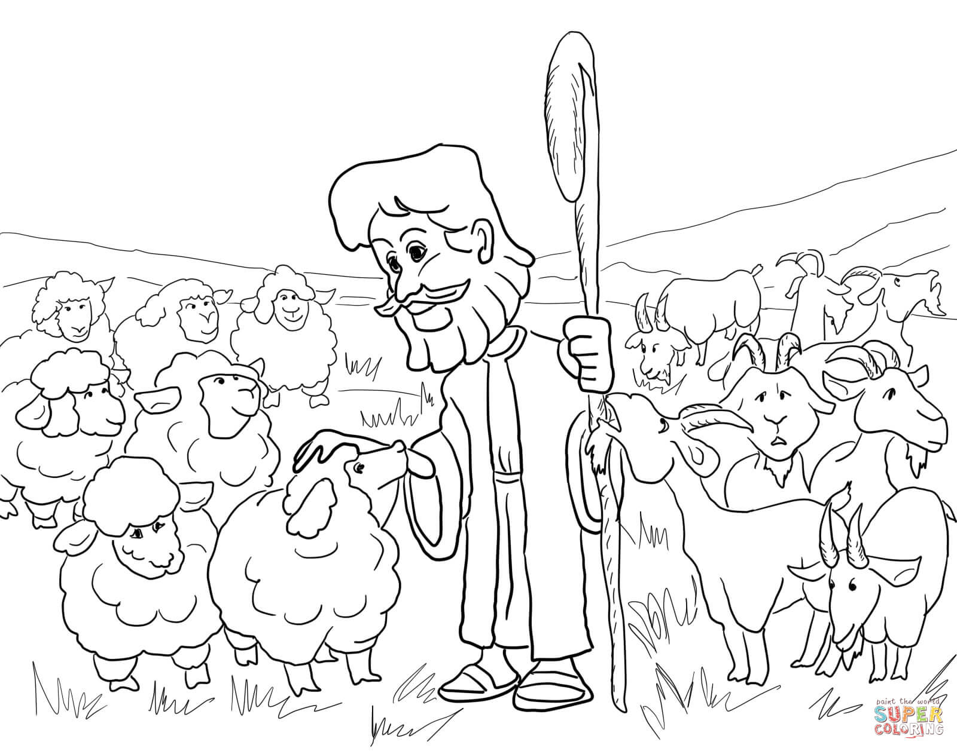
He will put the sheep on his right and the goats on his left."
Matthew 25:33 (NIV)

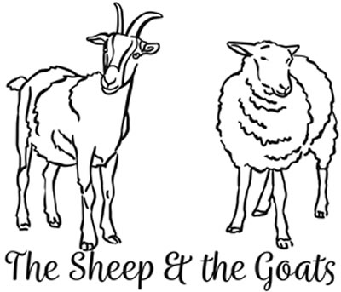

Choose the answer that best matches the definition.



