

Copyright © Sermons4Kids, Inc.
May be reproduced for Ministry Use
Children’s Worship Bulletin

Dance with All Your Might

2 Samuel 6:1-5, 12-19

Your Church Name
Any Town, Anywhere

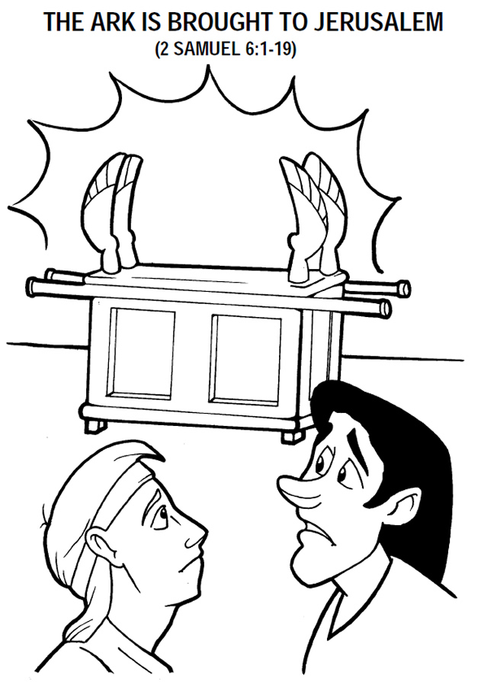
Copyright © CalvaryCurriculum.com
Used by Permission

Each number represents a letter of the alphabet. Substitute the
correct letter for the numbers to reveal the coded words.

