Crossword Puzzle

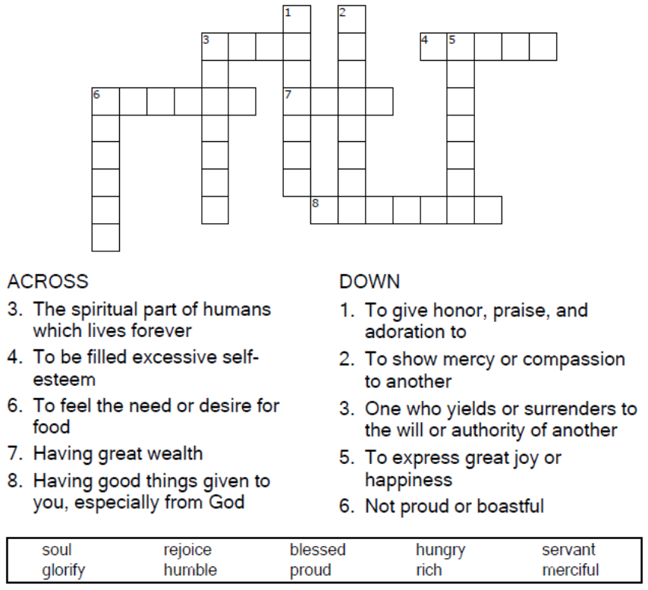

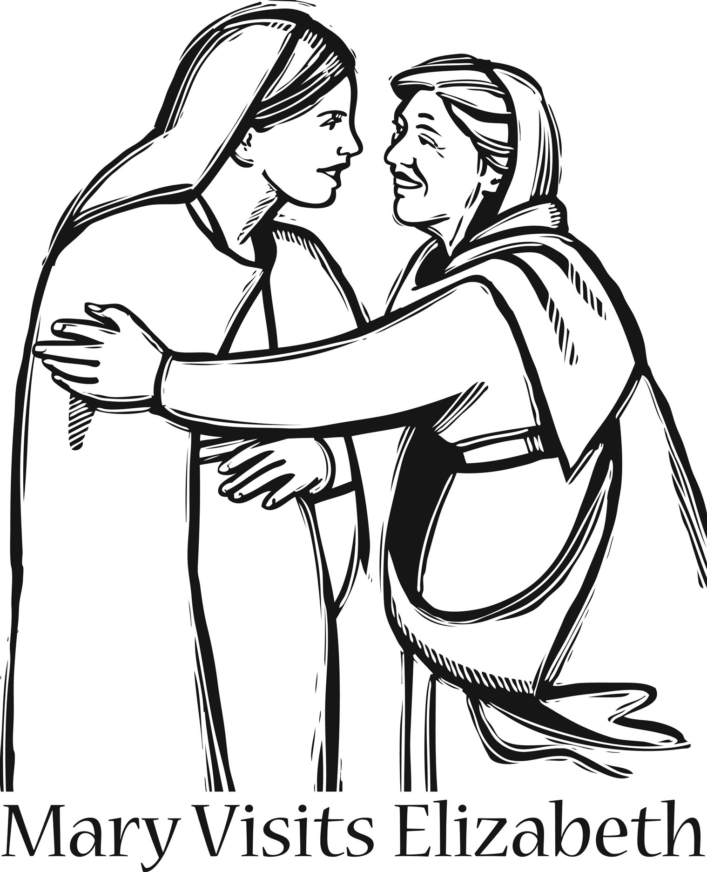

Copyright © Sermons4Kids, Inc.
May be reproduced for Ministry Use
Children’s Worship Bulletin

Mary Visits Elizabeth

Luke 1:39-45

Word Search Puzzle

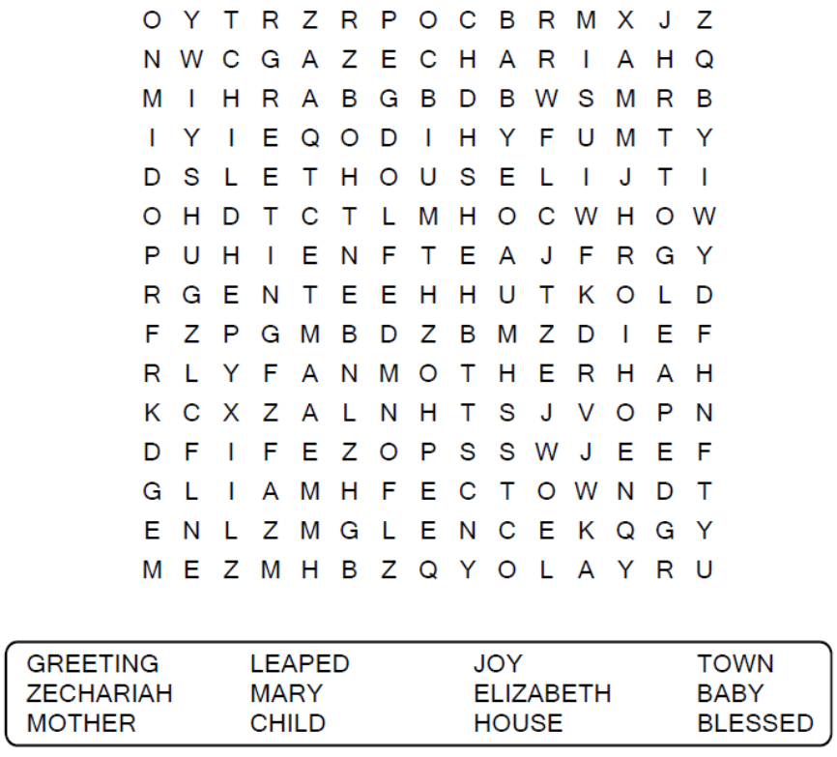

Your Church Name Here
Anytown, Anywhere
Coloring Page

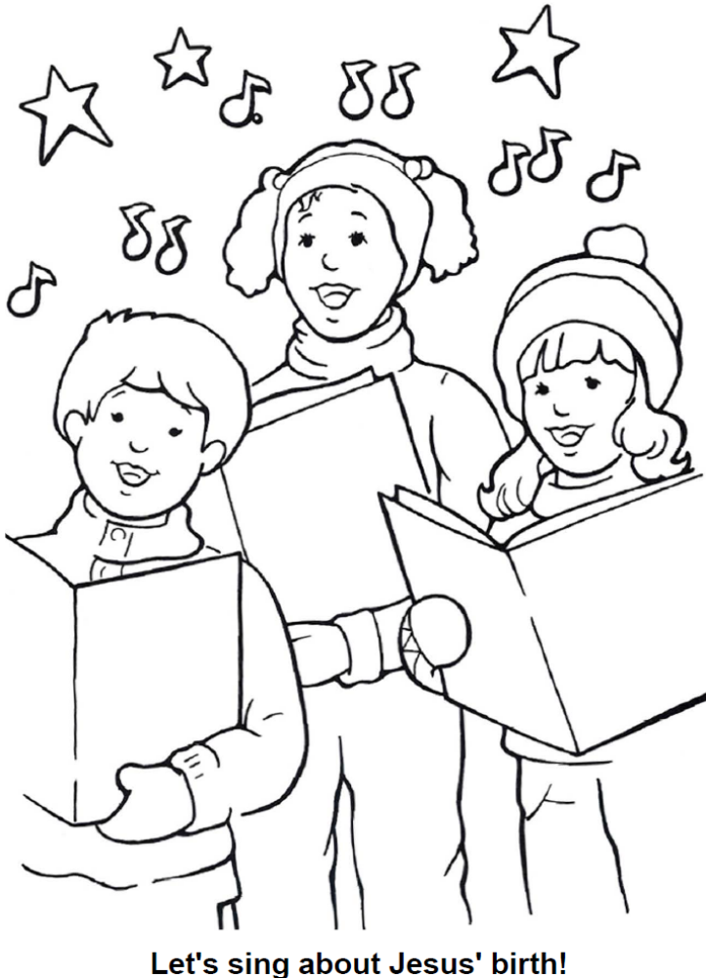

From Thru-the-Bible Coloring Pages © Standard Publishing.
Used by permission. Coloring Books may be purchased from
Standard Publishing, www.standardpub.com, 1-800-323-5473.
Decoder Puzzle

Each number represents a letter of the alphabet. Replace
each number in the puzzle with the corresponding letter
to reveal the secret words.





