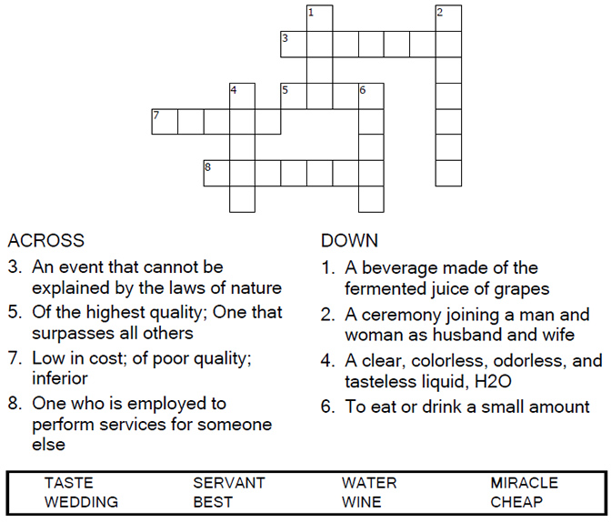

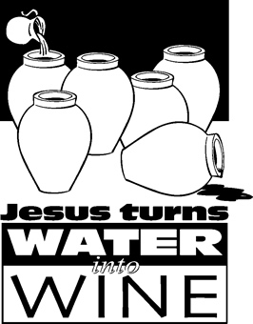
Copyright © Sermons4Kids, Inc.
May be reproduced for Ministry Use
Children’s Worship Bulletin

The Miracle Worker

John 2:1-11

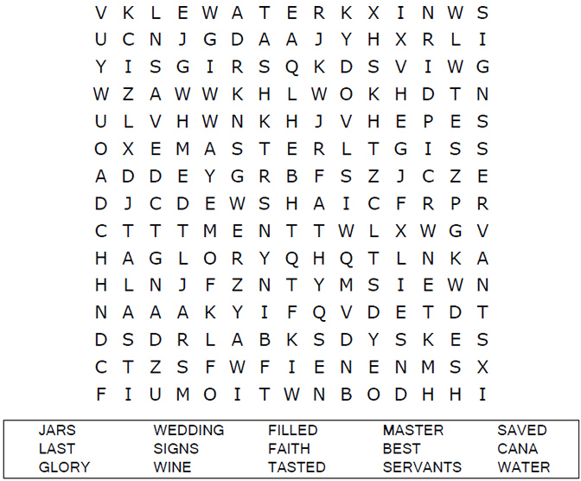

Your Church Name Here
Anytown, USA

Each number represents a letter of the alphabet. Substitute the correct letter for the numbers to reveal the coded words.

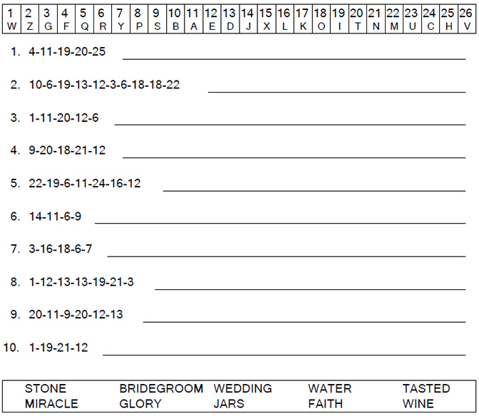
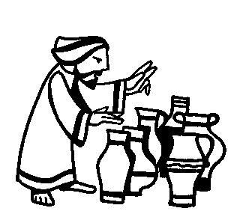

Complete the sentences by filling in the blanks with the correct words from the word bank below the puzzle. You can check your answers in Luke 3:15-16, 21-22 (NIV)

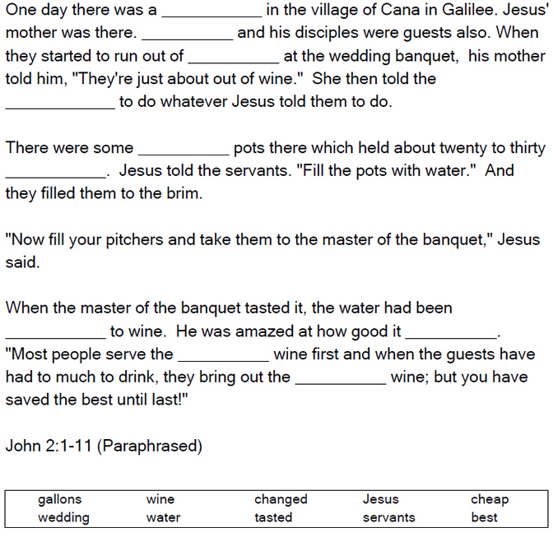

The Miracles of Jesus



