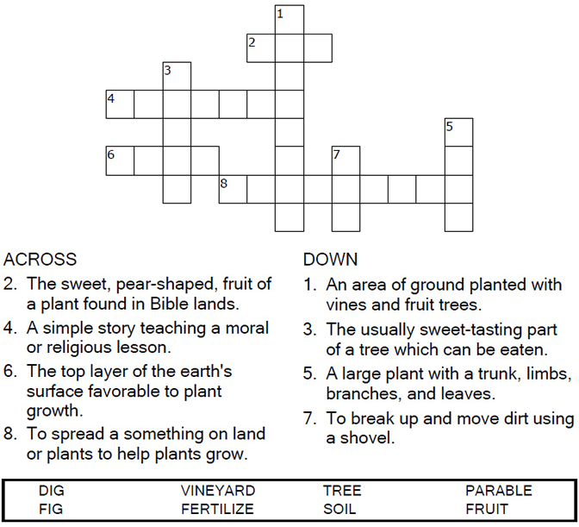

Copyright © Sermons4Kids, Inc.
May be reproduced for Ministry Use

Children’s Worship Bulletin

Living a Fruitful Life

Luke 13:1-9

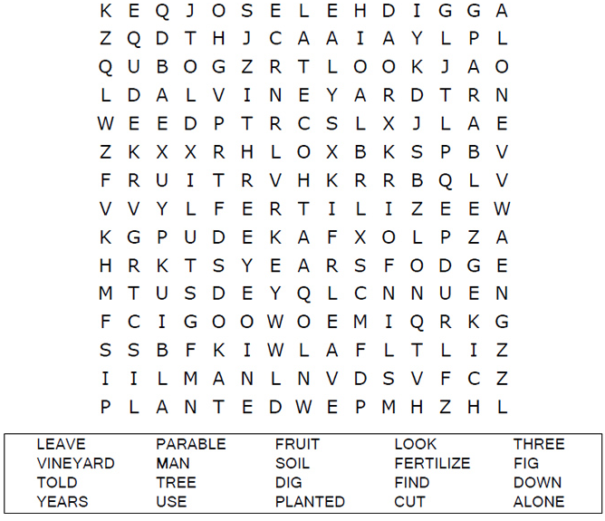
Your Church Name Here
Anytown, USA

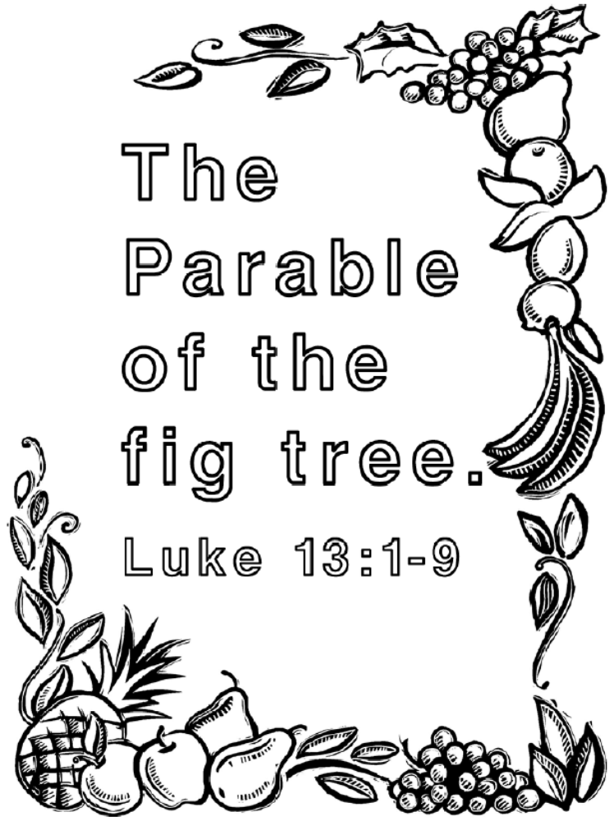
God wants us to bear good fruit!



